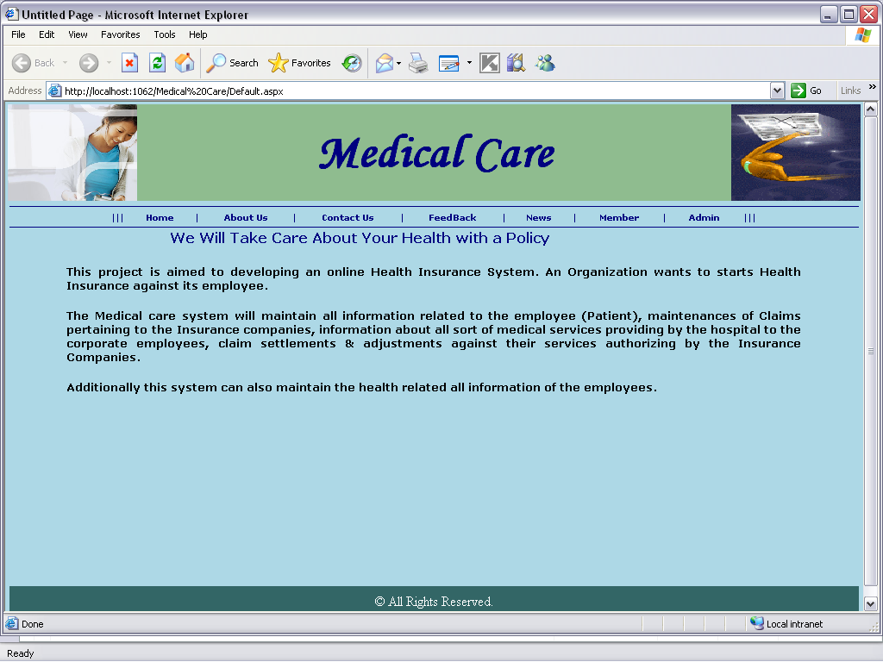
Pagename: Home
Fields: contain child pages
Process: when clicking child pages navigates to their pages
Table: no
Stored procedure:no

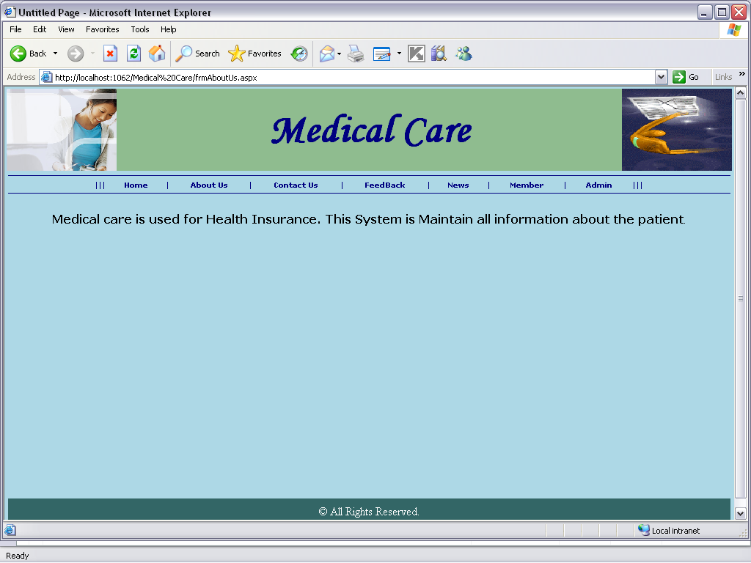
Pagename: About us
Fields: static

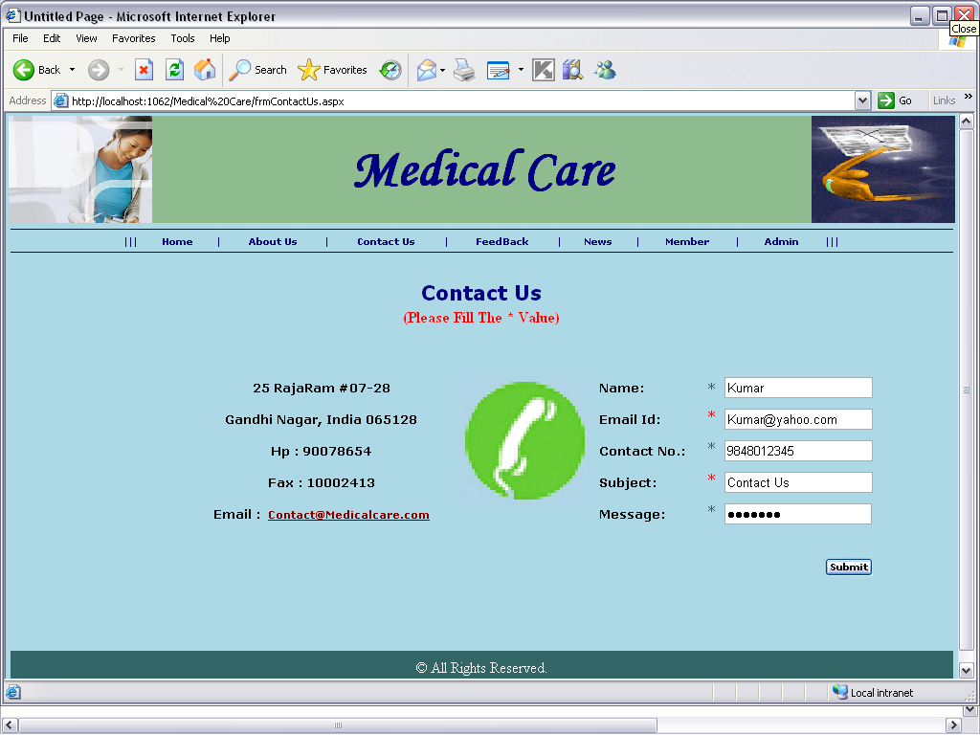

Pagename: Contact Us
Fields: name,email,no,sub,msg
Process: loads the user contact details
Table: no
Stored procedure:no
Remarks: enter details
Error: no

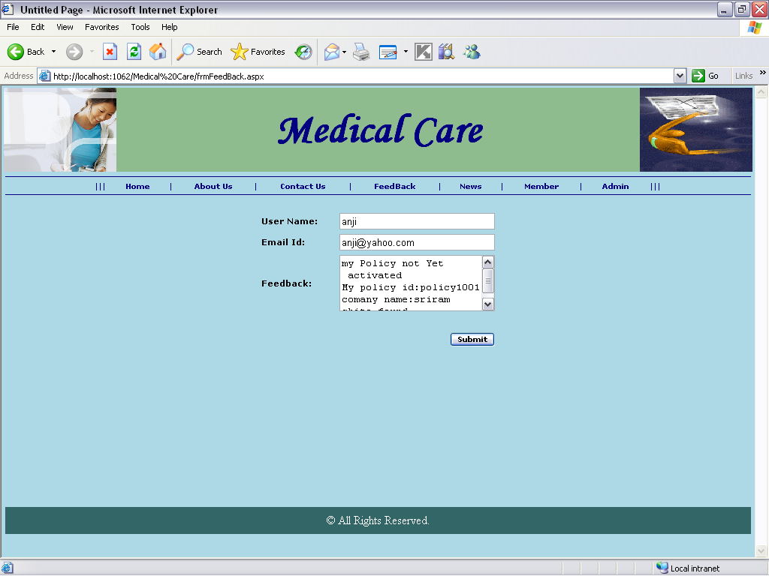

Pagename: Feed Back
Fields: user name,email id, feed back
Process: saves the feed back
Table: no
Stored procedure:no
Remarks: enter into fields
Error: no

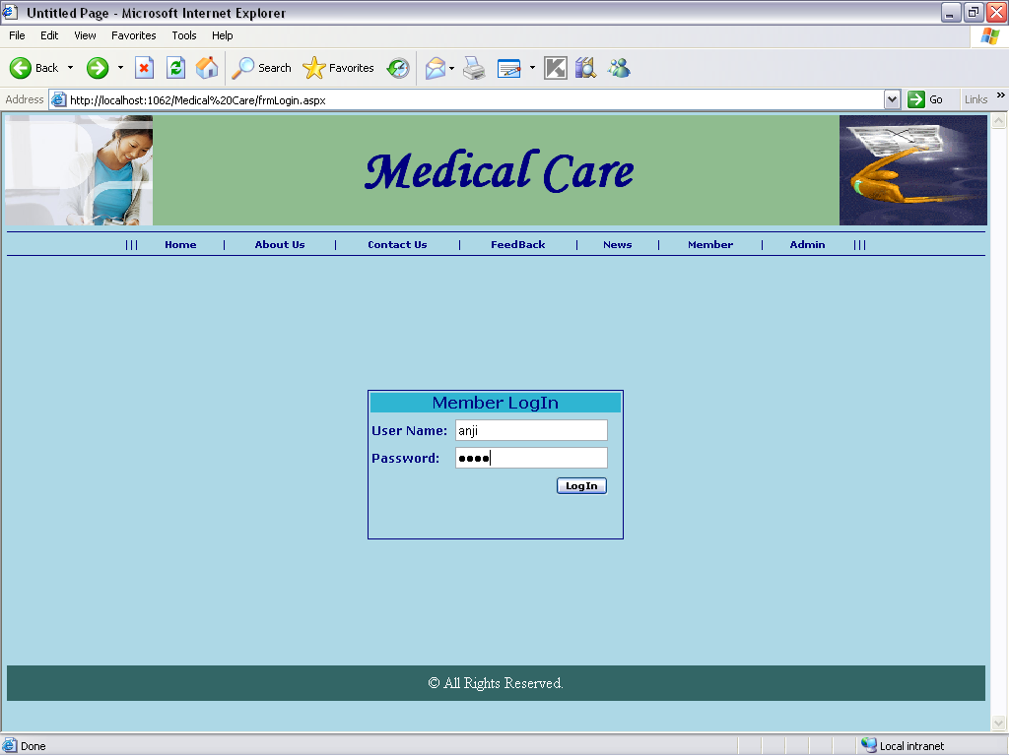
Pagename: Member
Fields: user name,password
Process: takes the user id and password
Table: no
Stored procedure:sp_emplogin
Remarks: enter username and password
Error: no

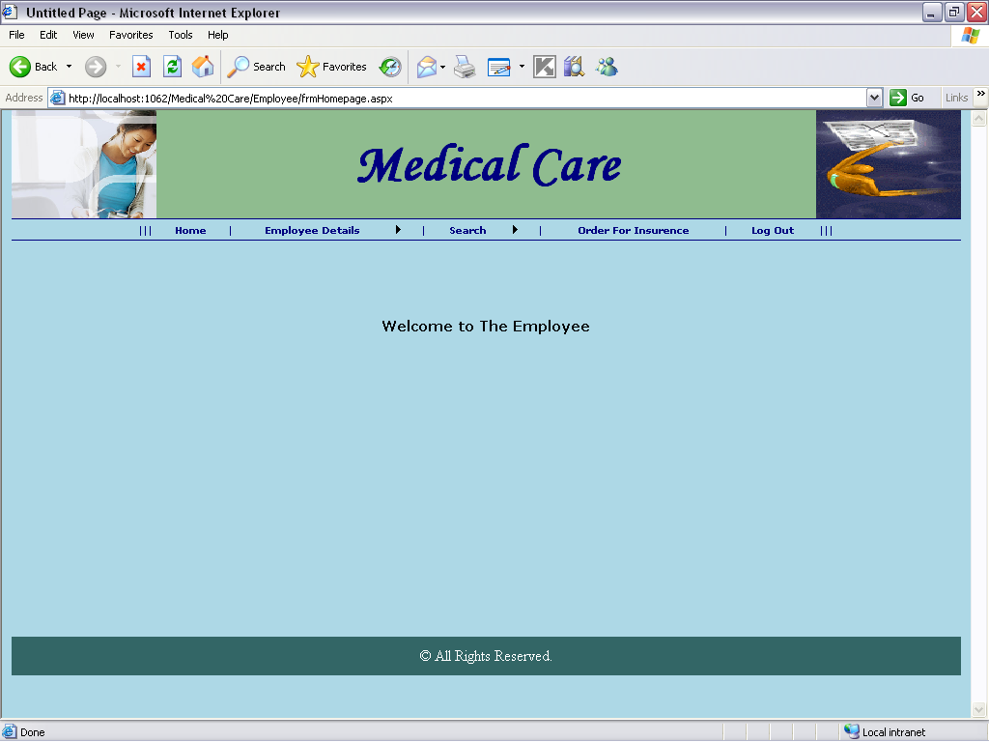

Pagename: Emp
Fields: child pages
Remarks: home page of emp
Error: no

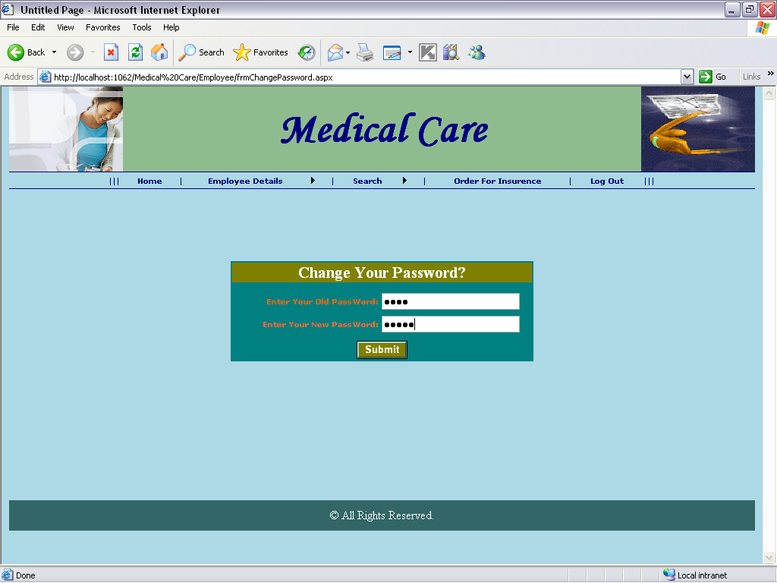

Pagename: change password page
Fields: old password,new password,submit
Process: saves new password
Table: no
Stored procedure:sp_update
Remarks: enter password
Error: no

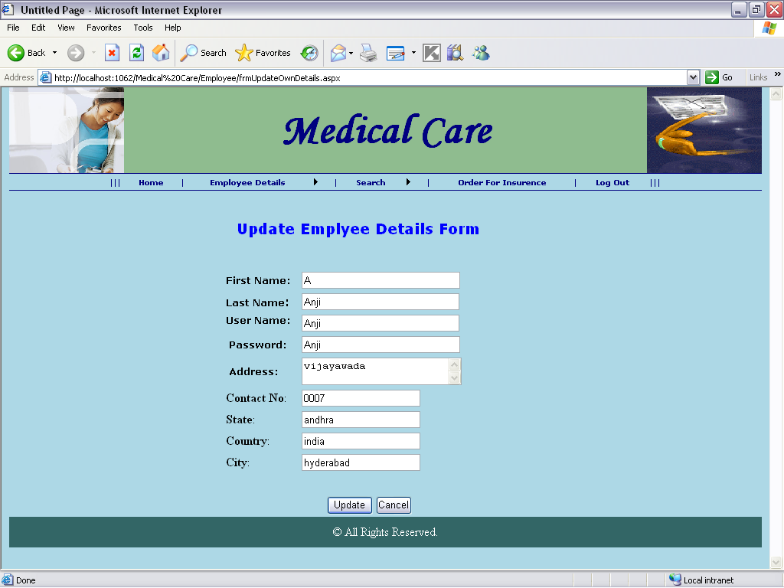

Pagename: update emp details
Fields: firstname,user name,password,address,contact no,state,country,city
Process: takes emp details
Table: no
Stored procedure: sp_upadateemp
Remarks: enter values
Error: no

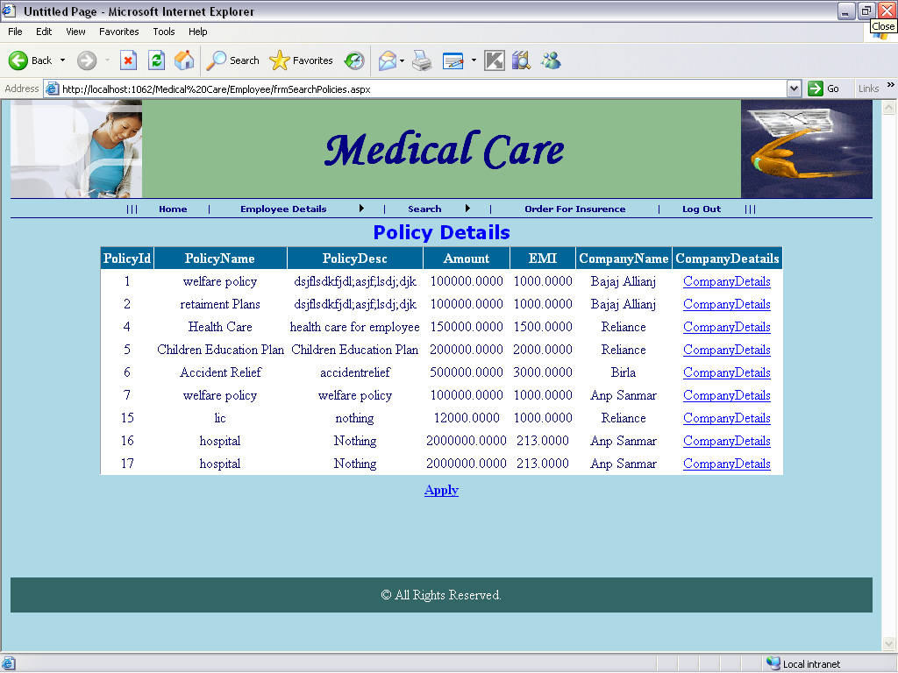

Pagename: policy details
Fields: grid view
Process: having policy details
Table: policies
Stored procedure:sp_polices
Remarks: appy
Error: no

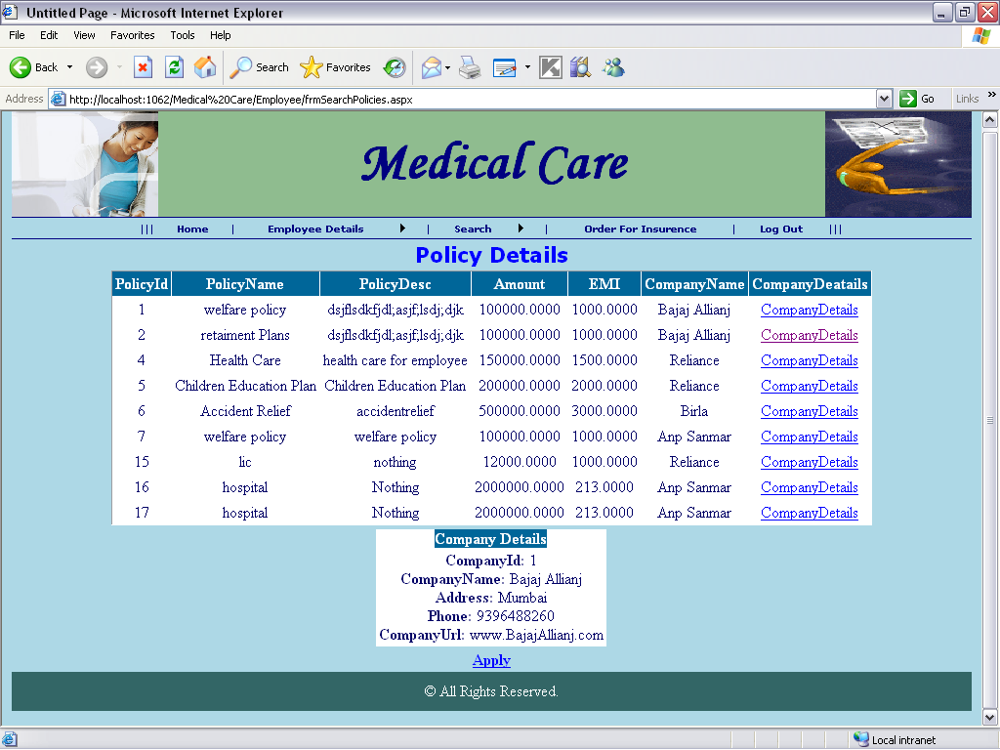

Pagename: policy details
Fields: grid view
Process: having policy details
Table: policies
Stored procedure:sp_polices
Remarks: appy
Error: no

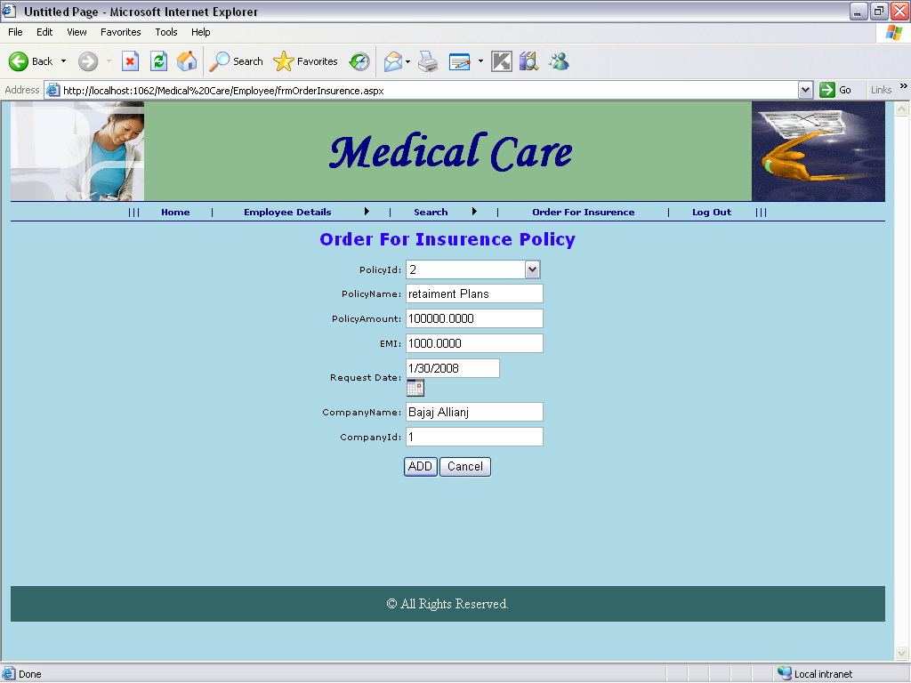

Pagename: Order for insurance policy
Fields: policy id,name,amount,emi,date,name,id
Process: taks the details
Table: no
Stored procedure:sp_order for insurence
Remarks: enyter into fields
Error: no

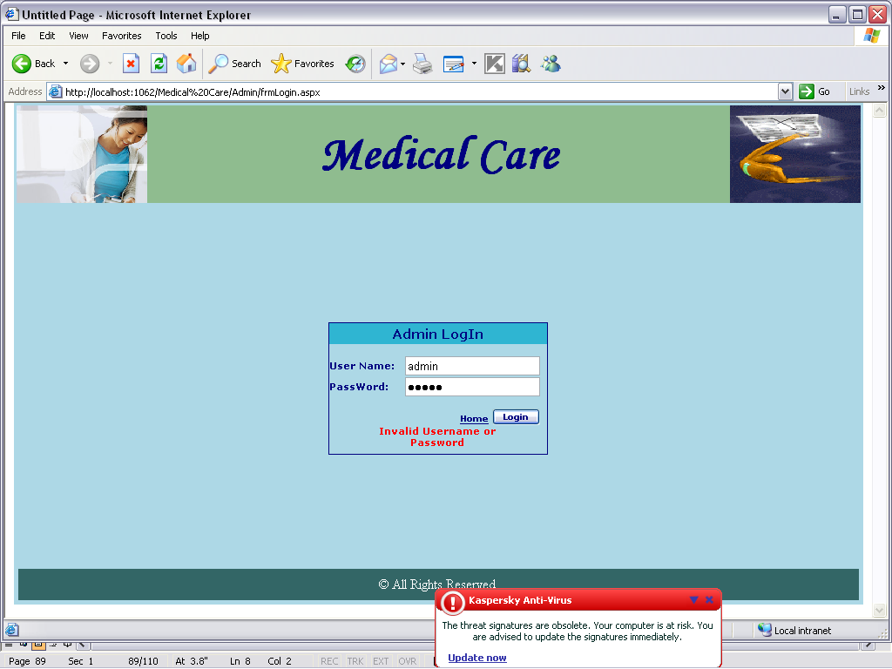

Pagename: admin login
Fields: username,password
Process: takes the credentials
Table: adminlogin
Stored procedure:sp_adminlogin
Remarks: enter admin details
Error: no

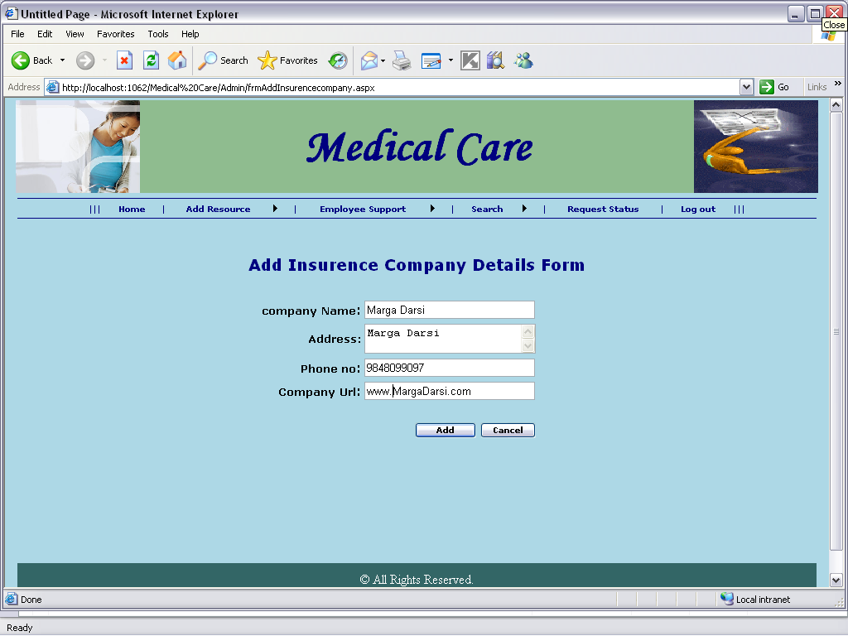
Pagename: Add insurance company details form
Fields: name,address,no,url
Process: takes details
Table: no
Stored procedure:sp_insurance
Remarks: enter values
Error: yes rectified

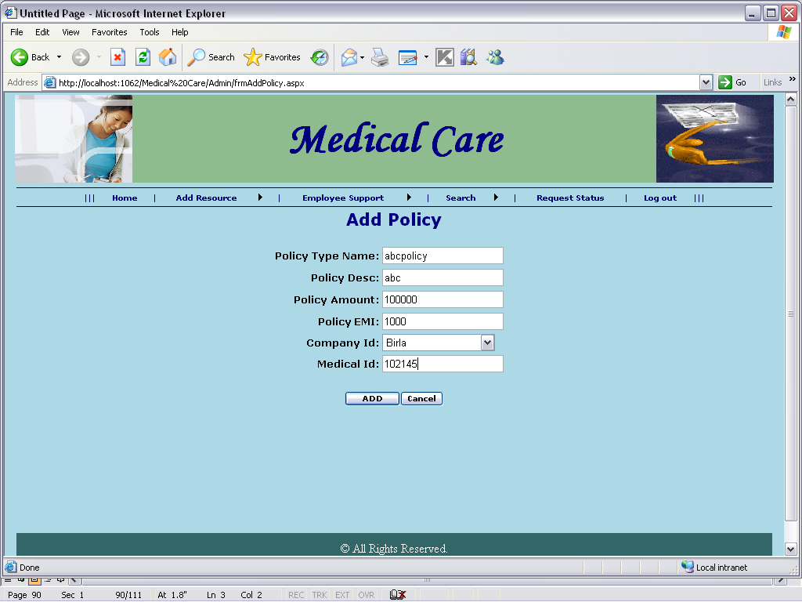

Pagename: Add policy
Fields: name,desc,amount,emi,id,medical id
Process: takes the values
Table: no
Stored procedure:sp_addpolicyonemp
Remarks: enter details
Error: no

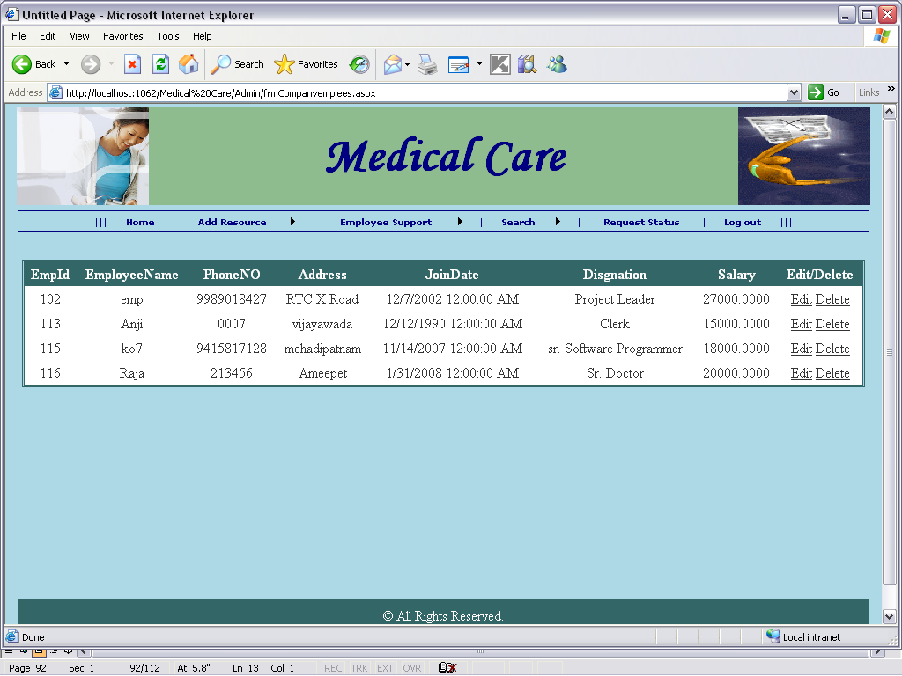

Pagename: emp details
Fields: grid view

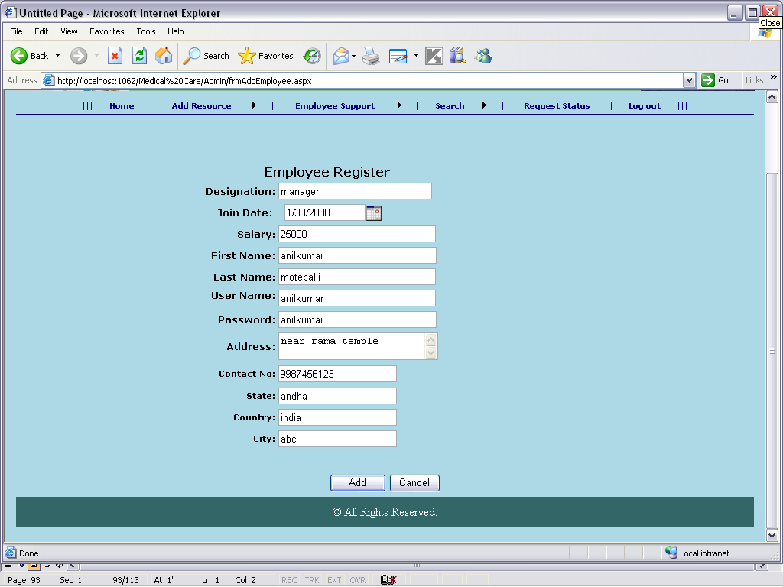

Pagename: employee register
Fields: des,date,salary,name,pwd
Process: takes emp details
Table: emp register
Stored procedure:sp_insertempregister
Remarks: enter details
Error: no

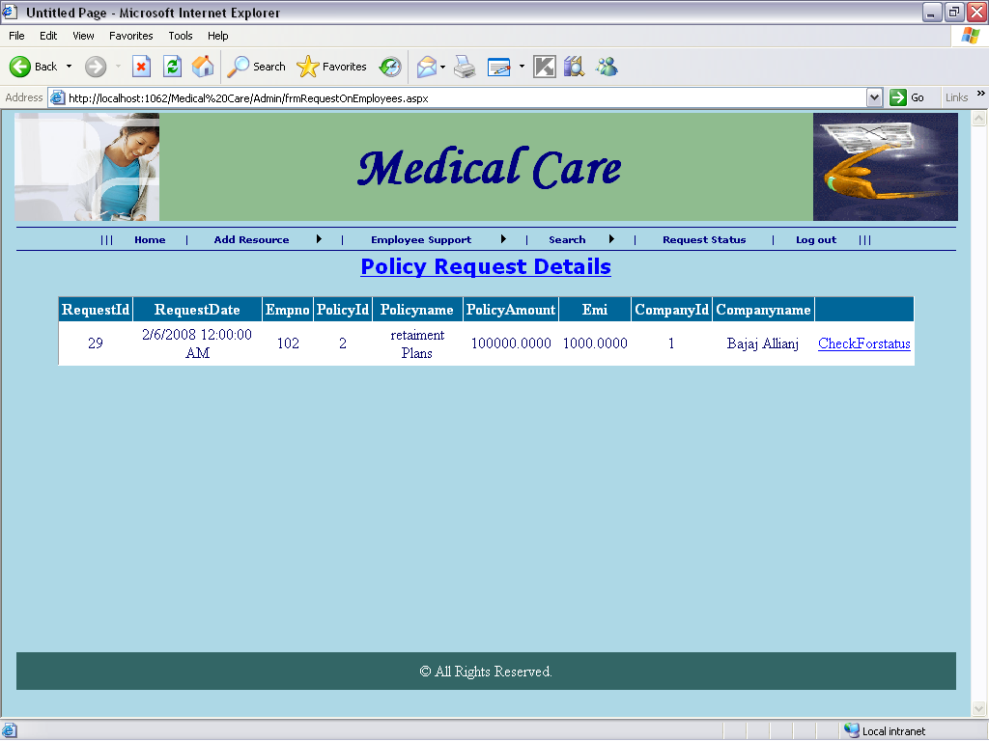
Pagename: policy request details
Fields: grid view
Table: no
Stored procedure:sp_policyrequest
Error: no

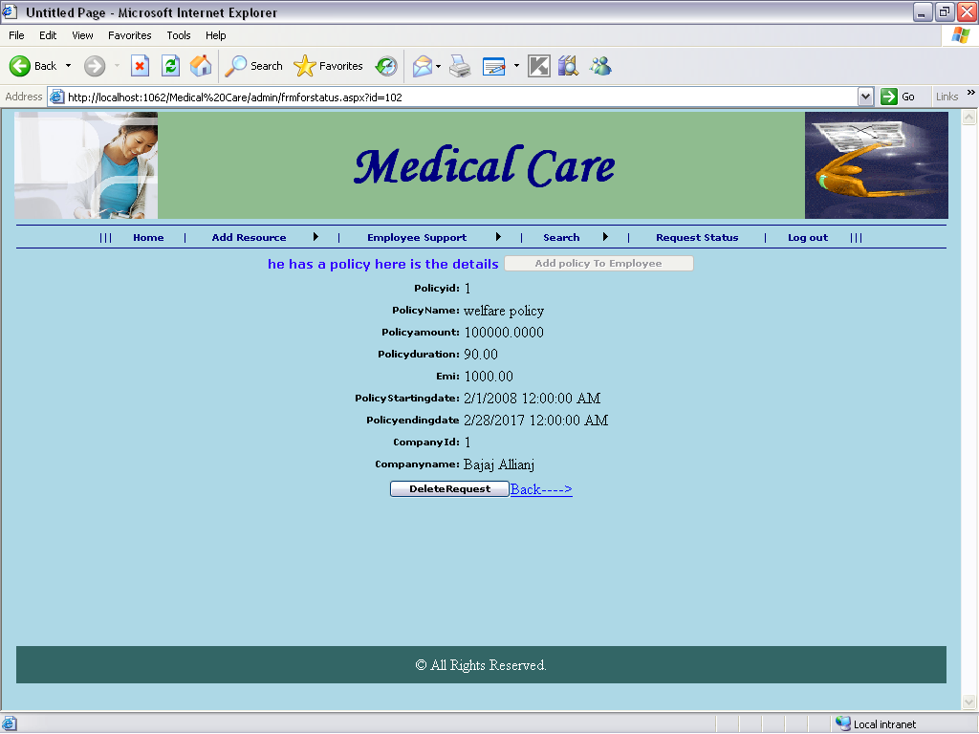

Pagename: policy details
Fields: delete
Process: details
Table: no
Stored procedure:sppolicydetails
Remarks: see details or delete
Error: no

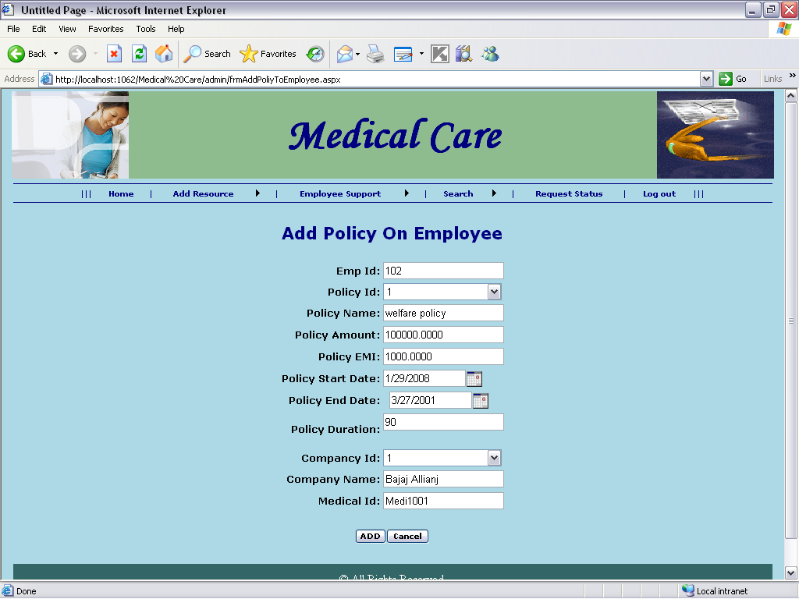

Pagename: Add policy on emp
Fields: id,name,date
Process: takes details
Table: no
Stored procedure:spaddpolicyonemp
Remarks: enter
Error: no

